Reconditioning of the SL-BOCLE and BOCLE Instruments

Andrew Osei Sakyi

Reconditioning of the SL-BOCLE and BOCLE Instruments

Andrew Osei Sakyi
11123436
Department of Chemical Engineering
University of Pretoria

Reconditioning of the SL-BOCLE and BOCLE Instruments
Abstract
In the year 2012 the tribology group of the University of Pretoria received lubricity testing instruments from Sasol as donations. They were:
- Scuffing-Load-Ball-On-Cylinder-Lubricity-Evaluator (SL-BOCLE)
- Ball-On-Cylinder-Lubricity-Evaluator (BOCLE)
The instruments were first commissioned upon arrival in the Tribology laboratory in 2012 because they were not in good working conditions. However, after a series of renovations in the Tribology laboratory over a space of 5 years, the instruments have fallen out of use. They have become redundant and several parts and wiring are lost or no longer functional.
In 2017’s CML 732 project much work was done to reinstate both machines into good working conditions. Several repair works have been done on both machines. And communication to the Opto 22 network has been established. Data logging and control was successfully done using Simulink and a good knowledge of the operating mechanism of these machines was obtained.
What remains is the acquisition of a ring mandrel assembly for the SL-BOCLE.
Keywords: BOCLE, scuffing, friction, wear, Opto 22

Contents
1. Introduction 1
2. Theory 2
2.1. Fundamental operating principles of the BOCLE 2
2.2. Instruments test methods 4
2.2.1. BOCLE 4
2.2.2. SL-BOCLE 4
2.2.3. Specifications for test methods on the BOCLE and SL-BOCLE 8
3. Work done on hardware 10
3.1. SL-BOCLE and BOCLE 10
3.2. Opto 22 and Junction box 11
3.3. SNAP Modules and Ethernet 11
4. Work done on software 12
4.1. Simulink 12
5. Control and logging of data 17
5.1. Humidity measurement 18
5.2. Frictional force measurement 19
6. Wiring network 20
Conclusions and Recommendations 23
References 23

Introduction
The Ball-On-Cylinder Lubricity Evaluator (BOCLE) is modelled after the Furey tester which was developed to study metallic contact and friction between sliding lubricated surfaces (Evans, 1988: 5). InterAv Incorporation first designed and produced a commercial unit of the BOCLE to test for wear and the SL-BOCLE (developed slightly later) to test for the load carrying capacity of aviation fuels. They were particularly designed for the US Air Force.
Sasol has owned a copy of these instruments for several years and upon acquisition of a newer model, the old models were donated to the University of Pretoria. Upon arrival, these instruments were commissioned in the Tribology laboratory, as they were not in proper working conditions. The lab used them secondly to the SRV machine and the HFRR to perform lubricity tests on samples. However, the Tribology lab has undergone several renovations over the past five (5) years and several wiring systems and connections to the BOCLES’s have been taken down, damaged and even some machine parts lost.
In 2017’s CML 732 project, the objective is to
- Recondition the machines
- Establish communication with the Opto 22 network
- Establish data logging and control using Simulink/LabVIEW
- Obtain a good knowledge on the operating mechanism of the machines
- Recollect and gather all the important literature about the instruments
Several software packages and hardware were used to achieve the set objectives.

Theory

Fundamental operating principles of the BOCLEs
Lubricity is one of the few fuel properties that may be degraded by certain refining processes. A great amount of effort has been expended in research and development of low-lubricity fuels and test method development since the early 1960’s. The Ball-On-Cylinder Lubricity Evaluator has emerged as a test tool to provide a quantitative value to fuel lubricity (Evans, 1988: 3).
The BOCLE schematic presented in Figure 1a comprises of a non-rotating 12.7mm diameter test ball (A) which is held in a vertically mounted holder (B) and forced against the highest point on the outer surface of a 44.5mm test cylinder/ring (C). The test ball and cylinder are placed inside a rectangular basin/reservoir (D) which contains 45-50mL of lubricant sample. The cylinder is mounted axially to a horizontal shaft (E) which goes through the sides of the basin’s upper detachable housing and is connected to a variable speed motor. The entire setup rests on a metallic base (F).
Figure 1 and 2 shows an illustration of the Ball-On-Cylinder configuration.
Figure 1: Ball-On-Cylinder configuration (adapted from CRC (1988))
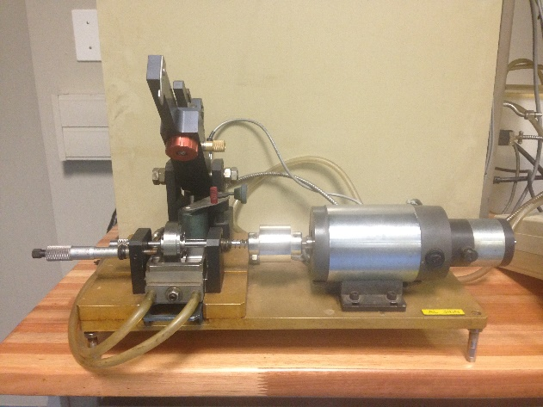
Figure 2: Ball-On-Cylinder configuration (Actual photograph taken at the Tribology lab)

Instruments test methods
The SL-BOCLE and BOCLE both work on the principle of a stationary ball pressed against a rotating ring. The rotating ring is positioned in the basin which is filled with the lubricant/fuel whose lubricity is investigated. The test cylinder is rotated at a fixed speed and receives a momentary exposure to the test fluid upon each revolution.
The coefficient of friction between the ball and cylinder is determined by Equation 1
$$μ=\frac{F}{N} (1)$$
where F represents the frictional force needed to overcome friction and, N is the load. The subsequent sections elaborates the testing method of each instrument.

BOCLE
The BOCLE is a wear test instrument. The wear scar generated on the test ball after a test is used as a measure of the fluid’s lubricating properties.

SL-BOCLE
The SL-BOCLE is a load carrying capacity (LCC) test instrument. The test performed examines the specific load at which the friction coefficient (µ) in the fuel exceeds 0.175. That specific load is termed as the failure load and is used to measure the lubricity behaviour of the fuel. Figure 3 shows how scuffing occurs. The scuffing wear graph in Figure 3 exceeds 0.175 after roughly 8 seconds whiles the mild wear is generally below 0.1.

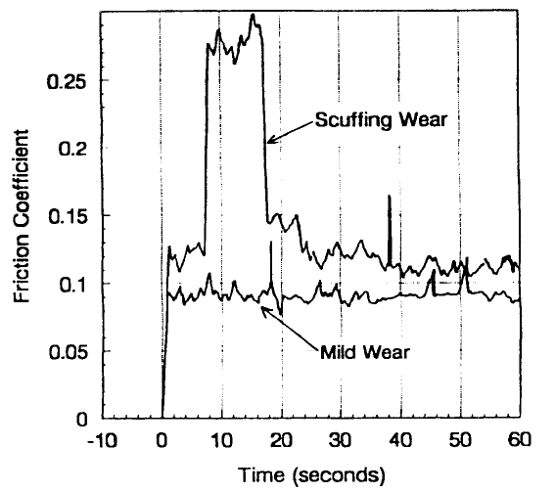
Figure 3: Scuffing load test (ASTM, 1999: 6)
In performing a scuffing load test, a test load sequence suggested by the U.S Army is deemed creditable for quickly identifying the failure load for a given fuel sample. The schematic is presented in Figure 4. The procedure follows that one moves from the left to right when selecting load. 2800g is the starting load (furthest left), if scuffing is observed at that load then one must select the next lower load to the right (follow the upward arrow).
If no scuffing is observed however, select the next higher load to the right (follow the downward arrow). This technique is continued till a value to the nearest 100g is known. However, if a higher level of accuracy is desired smaller test load can be used as well.

Figure 4: Recommended load sequence (in grams) for the SL-BOCLE (U.S. Army, 1994: 11)

Specifications for test methods on the BOCLE and SL-BOCLE
The operating conditions and specifications for the apparatus used in performing tests on the BOCLE and SL-BOCLE are detailed in Table 1.
Table 1: Specification for test methods (U.S. Army, 1994: 3)
Parameter | SL-BOCLE  (ASTM D6078, 1998: 1-9) | BOCLE  (ASTM D5001-90a, 1995: 1-6)
Type of fuel evaluated | Diesel | Aviation
Test ring | SAE 8720 steel  Rockwell C  HRC 58 - 62  Surface roughness  0.04 - 0.15 | SAE 8720 steel  Rockwell C  HRC 58 - 62  Surface finish 0.56 - 0.71
Test ball | AISI No. E-52100  Diameter 12.7 mm  HRC 64 - 66  5 - 10 EP finish | AISI No. E-52100  Diameter 12.7 mm  HRC 64 - 66  5 - 10 EP finish
Aeration pre-treatment of fuel (at Humidity and Temperature specified) | 0.5 L/min through fuel  3.3 L/min over fuel  15 min | 0.5 L/min through fuel  3.3 L/min over fuel  15 min
Fuel volume (mL) | 50 ± 1 | 50 ± 1
Humidity (%) | 50 ± 1 | 10 ±0.2
Temperature (°C) | 25 ± 1 | 25 ± 1
Aeration (mL/min) | 3.8 | 3.8
Applied load (g) | 500 (break in)  500 to 5000 (incremental) | 1000 (500 weight)
Rotation speed (rpm) | 525 ± 1 | 240 ± 1
Duration | 30 s (break in)  60 s (test) | 30 ± 0.1 min
Lubricity evaluated by | Load carrying ability. Smallest load for  µ >= 0.175 | Average wear scar size  Wear scar shape and appearance
Several changes to the instrument and repair works had to be done on both BOCLEs to recondition them. Hardware and software modifications were needed to bring the instruments up to their correct state. The subsequent section elaborates several changes that were made.

Work done on hardware

SL-BOCLE and BOCLE
At the start of the project I accessed the working conditions of both instruments and noticed that the friction measurement line had been severed in both BOCLEs. The cable that links the friction display unit to the circuit needed to be rewired to enable friction measurement and this was done.
Another important thing was because the instrument stood idle and unused for several years many parts have fallen apart or experienced rust. Example, the arm lift actuator knob on the BOCLE was broken, and upon inspection it was detected that the nut was damaged (rusted) and needed replacement. A new nut was installed to make the knob functional again. The line used to control the motor speed on the BOCLE had also been removed, the BOCLE wiring diagram was used as a guide for correcting this problem.
On the SL-BOCLE, the wires measuring the motor speed (line 556) and that used to control the speed (line 557) was out of place. They were rewired back to the motor speed display and motor DC supply respectively.
Another crucial problem was; tremendous difficulty was observed when identifying signals inside the machines because the wires were lumped together using cable ties. All the wires in both machines were appropriately labelled and this made working on the instruments less strenuous.
One more factor was the instruments had accumulated dust over the years and required intense cleaning. Additionally, the water in the bubble assembly of the humidifier was murky/dirty and had to be changed. Various cleaning detergents were used on both instruments to restore them back to a neat condition.

Opto 22 and Junction box
The wiring diagram for the wiring inside the junction box for both BOCLEs was found in the BOCLEs red file in the library section of the Tribology lab. It had already been drawn by Mr. Jacques Langenhoven who worked on the instruments in 2012 when they first arrived.
The same wiring diagram was used to lay the wiring again for both instruments in a new/unused junction box. But additional 12AWG and 10AWG DIN rail terminals (2.5mm²) and fuses were added to the junction box as the terminals in the box were not enough. I found the wires and the trunking he used in one of the boxes in the lab. And those were reused for the project so there was no need to purchase wires for this section.
In the Opto box setup there were two wiring ports already created on the box and the BOCLEs were connected through those ports. The wires in the trunking from the BOCLEs junction box were connected to fourteen (14) 12AWG DIN rail terminals inside the Opto box. This was again connected to another fourteen (14) DIN rail terminals before final connection to the SNAP modules were done.

SNAP Modules and Ethernet
The SNAP modules used in this project were mostly recovered from the ones used back in 2012. But it was observed that one of the SNAP AITM (±150mV) modules was no longer working and needed to be replaced. A SNAP AITM (±150mV) module was borrowed from the Process Control Laboratory to this effect.
Again the SNAP AOV (0 - 10V) module that was used back in 2012 was now been used to connect the humidifier instrument in the lab and was no longer available. I contacted Mr. Mike Harrison from OPTO 22 to send me a quote for this module.
The connection to the Ethernet was done via Opto 4. The IP address is 137.215.117.266.

Work done on software

Simulink
The Simulink model was originally developed in 2012. And since much of the program worked accurately, very little changes were made. I changed the sampling time from -1 (inherited) to one minute. This prevents excessive data points from being generated during a run.
The interface (program) however for the SL-BOCLE and the BOCLE are quite similar. In both cases the output/measured values are on the right whereas the inputs are on the left. The following are inputs that are required from the user:
- Temperature setpoint
- Motor speed setpoint
- Motor on/off
- Heating/Cooling
The Heating/Cooling function on the program is used to control temperature. The allowable difference between the setpoint and measurement is adjusted by a switch which uses a “bigger than” criteria. The Simulink model for the machines is presented in Figure 5.
The “Signal conditioning” subnet mask is presented in Figure 6 for the SL-BOCLE and Figure 7 for the BOCLE. What it contains are the calibration constants, noise filters and the signal transformations.

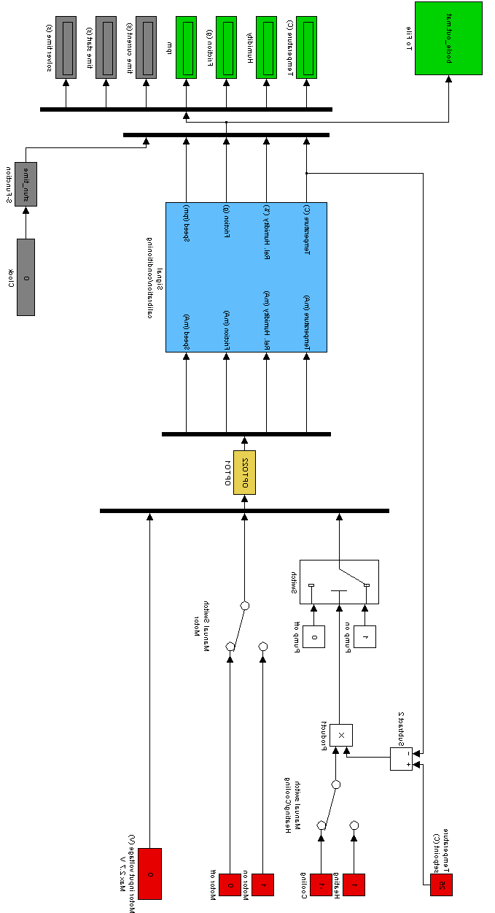
Figure 5: Simulink program
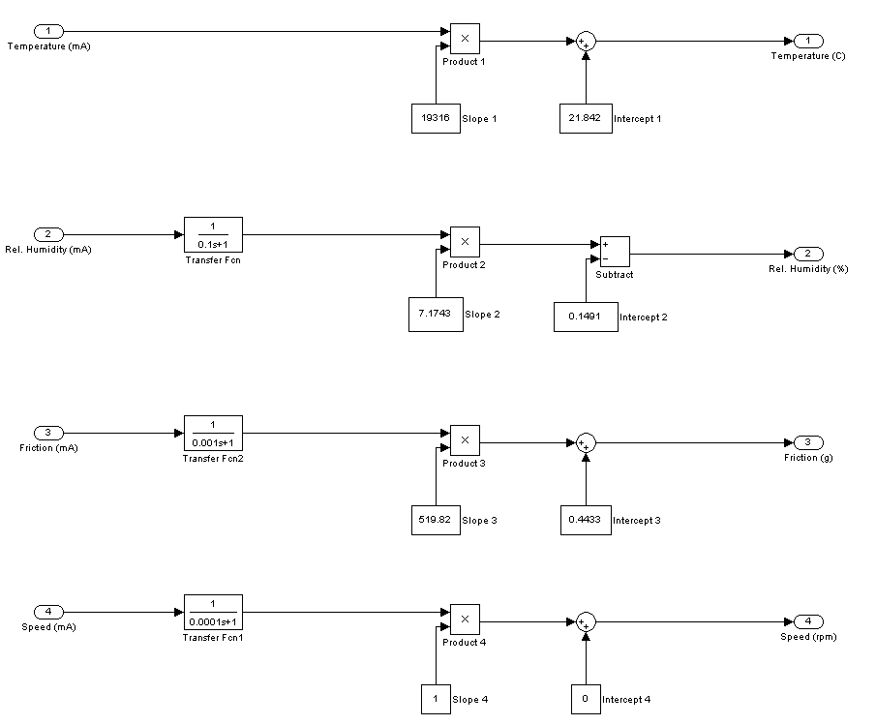
Figure 6: Signal conditioning subnet mask for the SL-BOCLE instrument
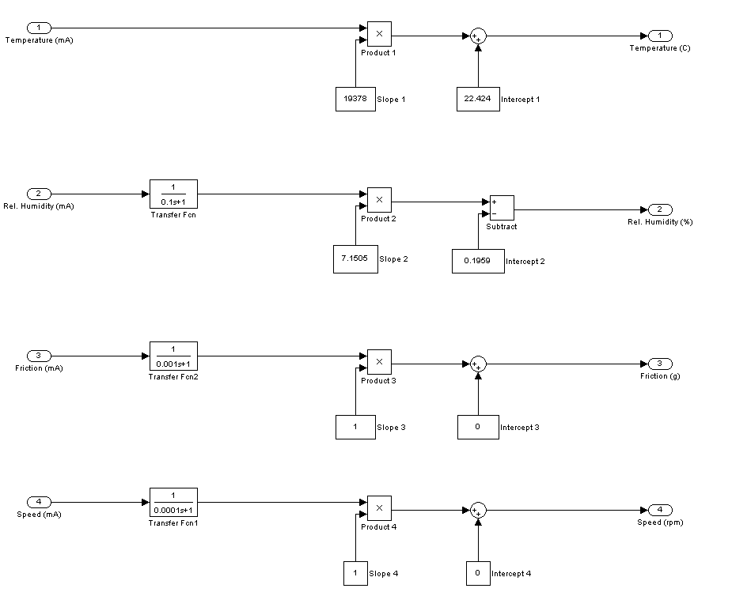
Figure 7: Signal conditioning subnet mask for the BOCLE instrument

Control and logging of data
The logging of data using Simulink is achieved by SNAP modules which are connected to the rack with a ‘’brain’’ unit which transfers information to the network using TCP/IP. The wiring and connection details of the SNAP modules to the OPTO system is presented in Table 2.
Table 2: Wiring and SNAP modules connection details to Opto system
Wiring no. | Signal Information | SNAP Module | Opto point no. (rack)
BOCLE
331 / 441 | Friction measurement | AIMA (± 20 mA) | 32
332 / 442 | Humidity measurement | AIMA (± 20 mA) | 33
333 / 443 | Temperature measurement | AITM (± 150 mV) | 25
334 / 444 | Temperature control | ODC5-I Digital output | 28
335 / 445 | Motor on/off | ODC5-I Digital output | 29
336 / 446 | Motor speed measurement | AIMA (± 20 mA) | 36
337 / 447 | Motor speed control | AOV (0-10V) | 21
SL-BOCLE
551 / 661 | Friction measurement | AIMA (± 20 mA) | 0
552 / 662 | Humidity measurement | AIMA (± 20 mA) | 1
553 / 663 | Temperature measurement | AITM (± 150 mV) | 24
554 / 664 | Temperature control | ODC5-I Digital output | 17
555 / 665 | Motor on/off | ODC5-I Digital output | 16
556 / 666 | Motor speed measurement | AIMA (± 20 mA) | 10
557 / 667 | Motor speed control | AOV (0-10V) | 20

Humidity measurement
The signal transformation for humidity measurement is detailed in Table 3. A graphical display of humidity measurement on Simulink is shown in Figure 8 and 9.
Table 3: Signal transformation for humidity measurement
Instrument | Wiring line | Output Voltage | Resistance (Min) | Input to Opto module
SL-BOCLE | 552/662 | 0-10 | 500 | 0-20mA
BOCLE | 332/442 | 0-10 | 500 | 0-20mA

Figure 8: Simulink signal calibration for humidity on BOCLE

Figure 9: Simulink signal calibration for humidity on SL-BOCLE

Frictional force measurement
Frictional force measurement and signal transformation details is presented in Table 4. Calibration of friction measurement for the BOCLE is presented in Figure 10. However, friction measurement for the SL-BOCLE is not shown as the ring and mandrel assembly was not found. That part of the instrument is missing/lost.
Instrument | Wiring line | Output Voltage | Resistance (Min) | Input to Opto module
SL-BOCLE | 551/661 | 0-4 | ±200 | 0-20mA
BOCLE | 331/441 | 0-1 | ±50 | 0-20mA

Figure 10: Frictional force signal calibration

Wiring network
The wiring network designed in 2012 was reverse engineered to connect both instruments to the junction box and Opto box. The changes made to the original diagram from Sasol was also maintained in 2017’s version.
The original author being Jacques Langenhoven redesigned the internal wiring diagram of the instruments (available on the attached CD) and the wiring diagram which is presented in Figure 11 and 12.
Figure 11: BOCLE Opto wiring diagram
Figure 12: SL-BOCLE wiring diagram

Conclusions and Recommendations
In general, a level of success was attained for both instruments, but more on the BOCLE than the SL-BOCLE. Data logging was successful in both instruments using Simulink. However the SL-BOCLE needs a ring mandrel and a new dryer assembly. Both machines require new pumps as temperature control was difficult.
It is recommended that routine maintenance and calibration should be exercised.

References
American Society for Testing and Materials (ASTM) (1999) " Standard test method for evaluating lubricity of diesel fuels by the Scuffing Load Ball-On-Cylinder Lubricity Evaluator", USA.
Evans, B (1988) “Aviation Fuel Lubricity Evaluation” CRC Aviation Group report to the Defence Document Center, Alexandria, Virginia
InterAV (sa a) "Friction force measurement capability for BOCLE machine", San Antonio, Texas, USA.
Tribology laboratory (2012) “T12 & T13 BOCLE, SL-BOCLE” University of Pretoria, Hatfield, South Africa
U.S. Army (1994) “The U.S. army scuffing load wear test”, San Antonio, Texas

